

**CODE OF HTML:**

<!DOCTYPE html>

<!-- Website - www.codingnepalweb.com -->

<html lang="en" dir="ltr">

<head>

<meta charset="UTF-8" />

<title>My Self info...</title>

<link rel="stylesheet" href="style.css" />

<!-- Fontawesome CDN Link -->

<link rel="stylesheet" href="https://cdnjs.cloudflare.com/ajax/libs/font-awesome/5.15.2/css/all.min.css" />

<meta name="viewport" content="width=device-width, initial-scale=1.0" />

</head>

<body>

<!-- Move to up button -->

<div class="scroll-button">

<a href="#home"><i class="fas fa-arrow-up"></i></a>

</div>

<!-- navgaition menu -->

<nav>

<div class="navbar">

<div class="logo"><a href="#">Welcome</a></div>

<ul class="menu">

<li><a href="#home">Home</a></li>

<li><a href="#about">About</a></li>

<li><a href="#skills">Skills</a></li>

<li><a href="#services">Services</a></li>

<li><a href="#contact">Contact</a></li>

<div class="cancel-btn">

<i class="fas fa-times"></i>

</div>

</ul>

<div class="media-icons">

<a href="#"><i class="fab fa-instagram"></i></a>

<a href="#"><i class="fab fa-whatsapp"></i></a>

<a href="#"><i class="fab fa-github"></i></a>

</div>

</div>

<div class="menu-btn">

<i class="fas fa-bars"></i>

</div>

</nav>

<!-- Home Section Start -->

<section class="home" id="home">

<div class="home-content">

<div class="text">

<div class="text-one">Hello,</div>

<div class="text-two">I'm DeepakRaj k</div>

<div class="text-three">Bachelor of Science in Computer Science</div>

<div class="text-four">From,<br>

Government Art's Collage (Autonomous), Thanthonimalai.

<br>

Karur.</div>

</div>

</div>

</section>

<!-- About Section Start -->

<section class="about" id="about">

<div class="content">

<div class="title"><span>About Me</span></div>

<div class="about-details">

<div class="left">

<img src="K. Deepakraj.jpg" alt="" />

</div>

<div class="right">

<div class="topic">Designing Is My Hobi</div>

<p>

I'am Deepakraj k, currently pursuing my IIIrd year of B.Sc in Computer Science. I have a strong passion for creating and developing web pages, and I'm proficient in programming languages such as C#, ASP.Net, PHP, HTML with CSS, and MYSQL. In my free time, I enjoy my life, I like nature , listening to music, Book Reading and etc..., . </p>

<br>

<p>

<b>Name: </b>&nbsp;&nbsp;&nbsp;&nbsp;&nbsp;&nbsp;&nbsp;&nbsp;&nbsp;&nbsp;&nbsp;&nbsp;&nbsp;&nbsp;&nbsp;Mr. Deepakraj k <br>

<b>Date of Birth:</b> &nbsp;&nbsp;&nbsp;18/08/2004 <br>

<b>Email: </b>&nbsp;&nbsp;&nbsp;&nbsp;&nbsp;&nbsp;&nbsp;&nbsp;&nbsp;&nbsp;&nbsp;&nbsp;&nbsp;&nbsp;&nbsp;&nbsp;&nbsp;vdeepakraj688@gmail.com <br>

<b>Phone:</b>&nbsp;&nbsp;&nbsp;&nbsp;&nbsp;&nbsp;&nbsp;&nbsp;&nbsp;&nbsp;&nbsp;&nbsp;&nbsp;&nbsp;&nbsp;&nbsp;9345333340 </p>

<b>Location:</b>&nbsp;&nbsp;&nbsp;&nbsp;&nbsp;&nbsp;&nbsp;&nbsp;&nbsp;&nbsp; Thanthonimalai <br>

<div class="button">

<button> <p><a href="https://en.m.wikipedia.org/wiki/Nature">https://dj.N.blackheart.org/deepak/Nature</a></p>Download CV</button>

</div>

</div>

</div>

</div>

</section>

<!-- My Skill Section Start -->

<!-- Section Tag and Other Div will same where we need to put same CSS -->

<section class="skills" id="skills">

<div class="content">

<div class="title"><span>My Skills</span></div>

<div class="skills-details">

<div class="text">

<div class="topic"> Skills</div>

<p>I'm understanding the Bachelor of Science in Computer Science language.

(i.g.) HTML, php, css and javascript.

<br>

<br>

<br>

i'm understanding the language of

above these average.</p>

<div class="">

<div class="num"></div>

</div>

</div>

<div class="boxes">

<div class="box">

<div class="topic">HTML</div>

<div class="per">80%</div>

</div>

<div class="box">

<div class="topic">CSS</div>

<div class="per">75%</div>

</div>

<div class="box">

<div class="topic">JavScript</div>

<div class="per">72%</div>

</div>

<div class="box">

<div class="topic">PHP</div>

<div class="per">65%</div>

</div>

</div>

</div>

</div>

</section>

<!-- My Services Section Start -->

<section class="services" id="services">

<div class="content">

<div class="title"><span>My Services</span></div>

<div class="boxes">

<div class="box">

<div class="icon">

<i class="fas fa-desktop"></i>

</div>

<div class="topic">Web Devlopment</div>

<p>i'm very intrested in web development. </p>

</div>

<div class="box">

<div class="icon">

<i class="fas fa-paint-brush"></i>

</div>

<div class="topic">Web Design</div>

<p>Know the principles of design. It's very important of any web design. I'm a web designer. </p>

</div>

<div class="box">

<div class="icon">

<i class="fas fa-chart-line"></i>

</div>

<div class="topic">Icon Design</div>

<p>Icon is a uniqe part of design.

It's very important.<br>

It is a art.</p>

</div>

</div>

</div>

</section>

<!-- Contact Me section Start -->

<section class="contact" id="contact">

<div class="content">

<div class="title"><span>Contact Me</span></div>

<div class="text">

<div class="topic">Enter Your Name:&nbsp;&nbsp;&nbsp;&nbsp;<input type="text"></div>

<div class="topic">Enter Your Email:&nbsp;&nbsp;&nbsp;&nbsp;&nbsp;&nbsp;<input type="email"></div>

<div class="topic"> Enter Your Message:<br> <textarea id="message" placeholder=" " style="height: 170px; width: 361px;"></textarea>

</div>

<div class="button">

<button>Submit</button>

</div>

</div>

</div>

</section>

<!-- Footer Section Start -->

<footer>

<div class="text">

<span>Created By <a href="#">DeepakRaj k</a> | &#169; 2023 All Rights Reserved</span>

</div>

</footer>

<script src="script.js"></script>

</body>

</html>

**CODE OF CSS:**

/* Google Font CDN Link */

@import url('https://fonts.googleapis.com/css2?family=Poppins:wght@400;500;600;700&family=Ubuntu:wght@400;500;700&display=swap');

*{

margin: 0;

padding: 0;

box-sizing: border-box;

text-decoration: none;

scroll-behavior: smooth;

}

/* Custom Scroll Bar CSS */

::-webkit-scrollbar {

width: 10px;

}

::-webkit-scrollbar-track {

background: #f1f1f1;

}

::-webkit-scrollbar-thumb {

background: #6e93f7;

border-radius: 12px;

transition: all 0.3s ease;

}

::-webkit-scrollbar-thumb:hover {

background: #4070f4;

}

/* navbar styling */

nav{

position: fixed;

width: 100%;

padding: 20px 0;

z-index: 998;

transition: all 0.3s ease;

font-family: 'Ubuntu', sans-serif;

}

nav.sticky{

background: #4070f4;

padding: 13px 0;

}

nav .navbar{

width: 90%;

display: flex;

justify-content: space-between;

align-items: center;

margin: auto;

}

nav .navbar .logo a{

font-weight: 500;

font-size: 35px;

color: #4070f4;

}

nav.sticky .navbar .logo a{

color: #fff;

}

nav .navbar .menu{

display: flex;

position: relative;

}

nav .navbar .menu li{

list-style: none;

margin: 0 8px;

}

.navbar .menu a{

font-size: 18px;

font-weight: 500;

color: #0E2431;

padding: 6px 0;

transition: all 0.4s ease;

}

.navbar .menu a:hover{

color: #4070f4;

}

nav.sticky .menu a{

color: #FFF;

}

nav.sticky .menu a:hover{

color: #0E2431;

}

.navbar .media-icons a{

color: #4070f4;

font-size: 18px;

margin: 0 6px;

}

nav.sticky .media-icons a{

color: #FFF;

}

/* Side Navigation Menu Button CSS */

nav .menu-btn,

.navbar .menu .cancel-btn{

position: absolute;

color: #fff;

right: 30px;

top: 20px;

font-size: 20px;

cursor: pointer;

transition: all 0.3s ease;

display: none;

}

nav .menu-btn{

color: #4070f4;

}

nav.sticky .menu-btn{

color: #FFF;

}

.navbar .menu .menu-btn{

color: #fff;

}

/* home section styling */

.home{

height: 100vh;

width: 100%;

background: url("images/background.png") no-repeat;

background-size: cover;

background-position: center;

background-attachment: fixed;

font-family: 'Ubuntu', sans-serif;

}

.home .home-content{

width: 90%;

height: 100%;

margin: auto;

display: flex;

flex-direction: column;

justify-content: center;

}

.home .text-one{

font-size: 25px;

color: #0E2431;

}

.home .text-two{

color: #0E2431;

font-size: 75px;

font-weight: 600;

margin-left: -3px;

}

.home .text-three{

font-size: 40px;

margin: 5px 0;

color: #4070f4;

}

.home .text-four{

font-size: 23px;

margin: 5px 0;

color: #0E2431;

}

.home .button{

margin: 14px 0;

}

.home .button button{

outline: none;

padding: 8px 16px;

border-radius: 6px;

font-size: 25px;

font-weight: 400;

background: #4070f4;

color: #fff;

cursor: pointer;

border: 2px solid transparent;

transition: all 0.4s ease;

}

.home .button button:hover{

border-color: #4070f4;

background-color: #fff;

color: #4070f4;

}

/* About Section Styling */

/* Those Elements Where We Have Apply Same CSS,

I'm Selecting Directly 'Section Tag' and 'Class' */

section{

padding-top: 40px;

}

section .content{

width: 80%;

margin: 40px auto;

font-family: 'Poppins', sans-serif;

}

.about .about-details{

display: flex;

justify-content: space-between;

align-items: center;

}

section .title{

display: flex;

justify-content: center;

margin-bottom: 40px;

}

section .title span{

color: #0E2431;

font-size: 30px;

font-weight: 600;

position: relative;

padding-bottom: 8px;

}

section .title span::before,

section .title span::after{

content: '';

position: absolute;

height: 3px;

width: 100%;

background: #4070f4;

left: 0;

bottom: 0;

}

section .title span::after{

bottom: -7px;

width: 70%;

left: 50%;

transform: translateX(-50%);

}

.about .about-details .left{

width: 45%;

}

.about .left img{

height: 400px;

width: 400px;

object-fit: cover;

border-radius: 12px;

}

.about-details .right{

width: 55%;

}

section .topic{

color: #0E2431;

font-size: 25px;

font-weight: 500;

margin-bottom: 10px;

}

.about-details .right p{

text-align: justify;

color: #0E2431;

}

section .button{

margin: 16px 0;

}

section .button button{

outline: none;

padding: 8px 16px;

border-radius: 4px;

font-size: 25px;

font-weight: 400;

background: #4070f4;

color: #fff;

border: 2px solid transparent;

cursor: pointer;

transition: all 0.4s ease;

}

section .button button:hover{

border-color: #4070f4;

background-color: #fff;

color: #4070f4;

}

/* My Skills CSS */

.skills{

background: #F0F8FF;

}

.skills .content{

padding: 40px 0;

}

.skills .skills-details{

display: flex;

justify-content: space-between;

align-items: center;

}

.skills-details .text{

width: 50%;

}

.skills-details p{

color: #0E2431;

text-align: justify;

}

.skills .skills-details .experience{

display: flex;

align-items: center;

margin: 0 10px;

}

.skills-details .experience .num{

color: #0E2431;

font-size: 80px;

}

.skills-details .experience .exp{

color: #0E2431;

margin-left: 20px;

font-size: 18px;

font-weight: 500;

margin: 0 6px;

}

.skills-details .boxes{

width: 45%;

display: flex;

flex-wrap: wrap;

justify-content: space-between;

}

.skills-details .box{

width: calc(100% / 2 - 20px);

margin: 20px 0;

}

.skills-details .boxes .topic{

font-size: 20px;

color: #4070f4;

}

.skills-details .boxes .per{

font-size: 60px;

color: #4070f4;

}

/* My Services CSS */

.services .boxes{

display: flex;

flex-wrap: wrap;

justify-content: space-between;

}

.services .boxes .box{

margin: 20px 0;

width: calc(100% / 3 - 20px);

text-align: center;

border-radius: 12px;

padding: 30px 10px;

box-shadow: 0 5px 10px rgba(0, 0, 0, 0.12);

cursor: default;

transition: all 0.4s ease;

}

.services .boxes .box:hover{

background: #4070f4;

color: #fff;

}

.services .boxes .box .icon{

height: 50px;

width: 50px;

background: #4070f4;

border-radius: 50%;

text-align: center;

line-height: 50px;

font-size: 18px;

color: #fff;

margin: 0 auto 10px auto;

transition: all 0.4s ease;

}

.boxes .box:hover .icon{

background-color: #fff;

color: #4070f4;

}

.services .boxes .box:hover .topic,

.services .boxes .box:hover p{

color: #0E2431;

transition: all 0.4s ease;

}

.services .boxes .box:hover .topic,

.services .boxes .box:hover p{

color: #fff;

}

/* Contact Me CSS */

.contact{

background: #F0F8FF;

}

.contact .content{

margin: 0 auto;

padding: 30px 0;

}

.contact .text{

width: 80%;

text-align: center;

margin: auto;

}

/* Footer CSS */

footer{

background: #4070f4;

padding: 15px 0;

text-align: center;

font-family: 'Poppins', sans-serif;

}

footer .text span{

font-size: 17px;

font-weight: 400;

color: #fff;

}

footer .text span a{

font-weight: 500;

color: #FFF;

}

footer .text span a:hover{

text-decoration: underline;

}

/* Scroll TO Top Button CSS */

.scroll-button a{

position: fixed;

bottom: 20px;

right: 20px;

color: #fff;

background: #4070f4;

padding: 7px 12px;;

font-size: 18px;

border-radius: 6px;

box-shadow: rgba(0, 0, 0, 0.15);

display: none;

}

/* Responsive Media Query */

@media (max-width: 1190px) {

section .content{

width: 85%;

}

}

@media (max-width: 1000px) {

.about .about-details{

justify-content: center;

flex-direction: column;

}

.about .about-details .left{

display: flex;

justify-content: center;

width: 100%;

}

.about-details .right{

width: 90%;

margin: 40px 0;

}

.services .boxes .box{

margin: 20px 0;

width: calc(100% / 2 - 20px);

}

}

@media (max-width: 900px) {

.about .left img{

height: 350px;

width: 350px;

}

}

@media (max-width: 750px) {

nav .navbar{

width: 90%;

}

nav .navbar .menu{

position: fixed;

left: -100%;

top: 0;

background: #0E2431;

height: 100vh;

max-width: 400px;

width: 100%;

padding-top: 60px;

flex-direction: column;

align-items: center;

transition: all 0.5s ease;

}

.navbar.active .menu{

left: 0;

}

nav .navbar .menu a{

font-size: 23px;

display: block;

color: #fff;

margin: 10px 0;

}

nav.sticky .menu a:hover{

color: #4070f4;

}

nav .navbar .media-icons{

display: none;

}

nav .menu-btn,

.navbar .menu .cancel-btn{

display: block;

}

.home .text-two{

font-size: 65px;

}

.home .text-three{

font-size: 35px;

}

.skills .skills-details{

align-items: center;

justify-content: center;

flex-direction: column;

}

.skills-details .text{

width: 100%;

margin-bottom: 50px;

}

.skills-details .boxes{

justify-content: center;

align-items: center;

width: 100%;

}

.services .boxes .box{

margin: 20px 0;

width: 100%;

}

.contact .text{

width: 100%;

}

@media (max-width: 500px){

.home .text-two{

font-size: 55px;

}

.home .text-three{

font-size: 33px;

}

.skills-details .boxes .per{

font-size: 50px;

color: #4070f4;

}

}

CODE WITH JAVASCRIPT:

// Sticky Navigation Menu JS Code

let nav = document.querySelector("nav");

let scrollBtn = document.querySelector(".scroll-button a");

console.log(scrollBtn);

let val;

window.onscroll = function() {

if(document.documentElement.scrollTop > 20){

nav.classList.add("sticky");

scrollBtn.style.display = "block";

}else{

nav.classList.remove("sticky");

scrollBtn.style.display = "none";

}

}

// Side NavIgation Menu JS Code

let body = document.querySelector("body");

let navBar = document.querySelector(".navbar");

let menuBtn = document.querySelector(".menu-btn");

let cancelBtn = document.querySelector(".cancel-btn");

menuBtn.onclick = function(){

navBar.classList.add("active");

menuBtn.style.opacity = "0";

menuBtn.style.pointerEvents = "none";

body.style.overflow = "hidden";

scrollBtn.style.pointerEvents = "none";

}

cancelBtn.onclick = function(){

navBar.classList.remove("active");

menuBtn.style.opacity = "1";

menuBtn.style.pointerEvents = "auto";

body.style.overflow = "auto";

scrollBtn.style.pointerEvents = "auto";

}

// Side Navigation Bar Close While We Click On Navigation Links

let navLinks = document.querySelectorAll(".menu li a");

for (var i = 0; i < navLinks.length; i++) {

navLinks[i].addEventListener("click" , function() {

navBar.classList.remove("active");

menuBtn.style.opacity = "1";

menuBtn.style.pointerEvents = "auto";

});

}

RESULT;

**INTRODUCTION OF WEB PAGE**



ABOUT:

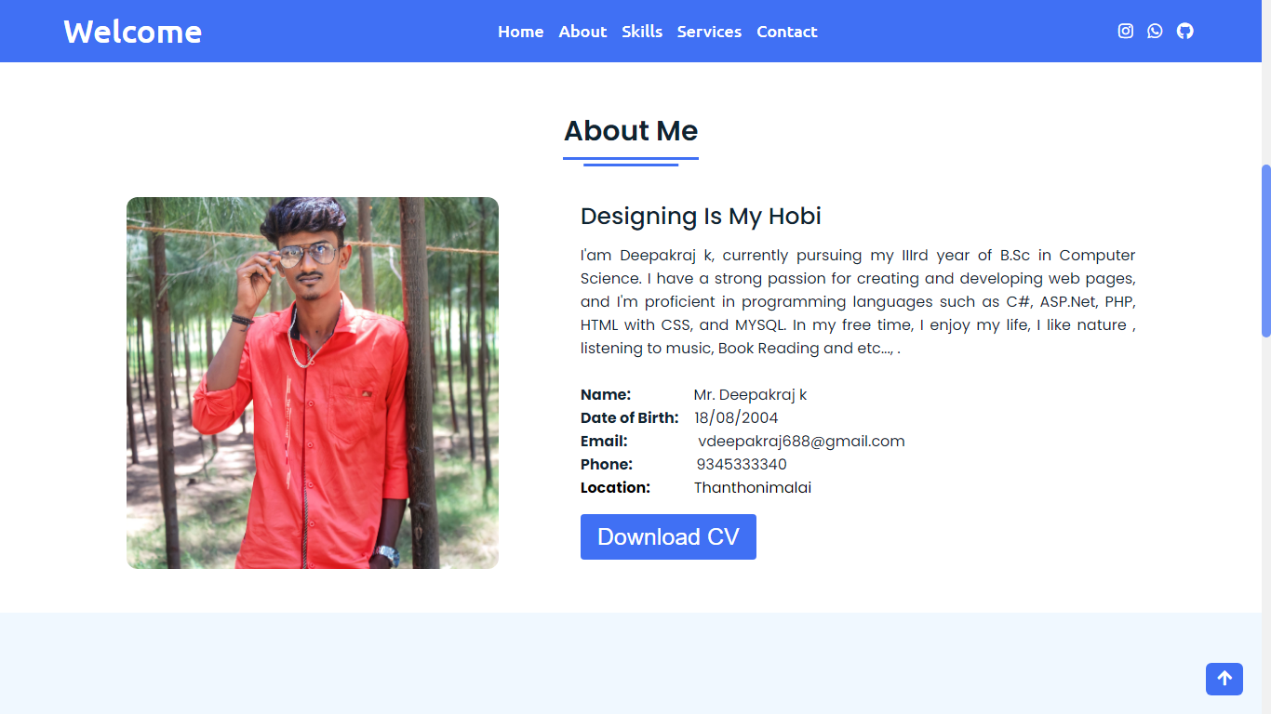

SKILL:

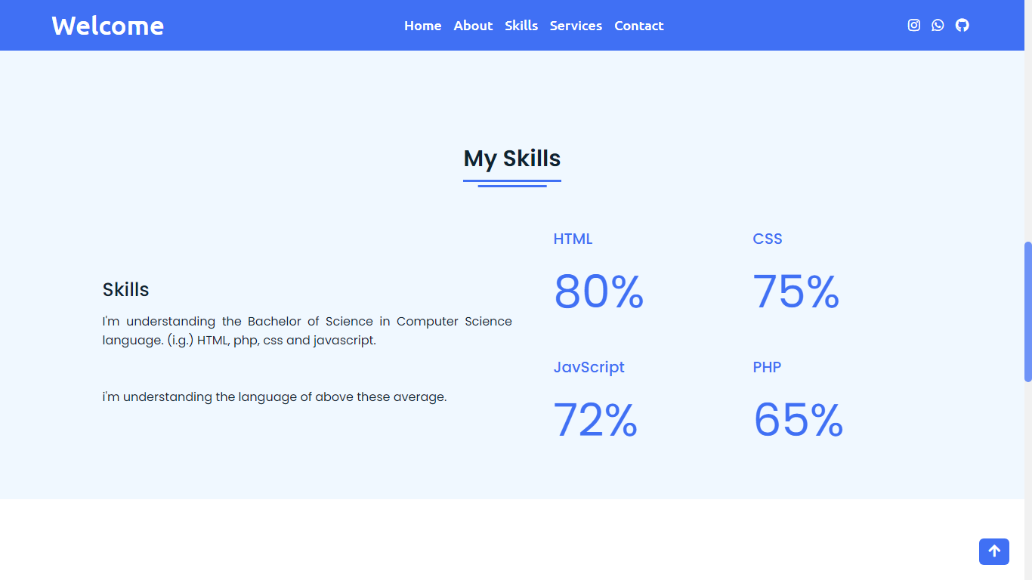

SERVICES:

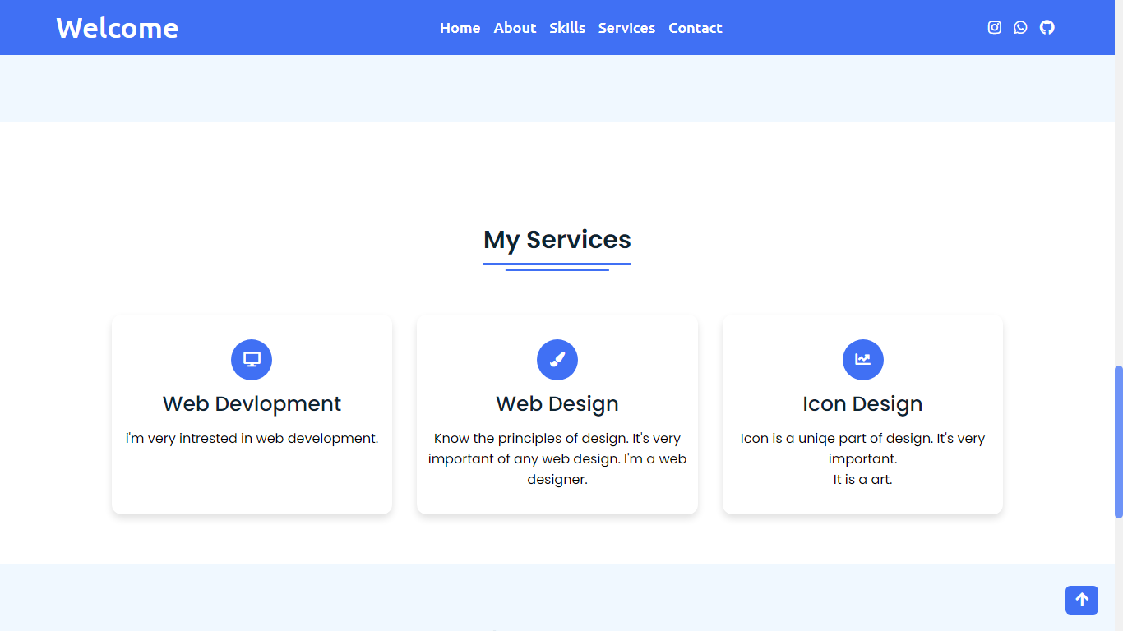

CONTACT:

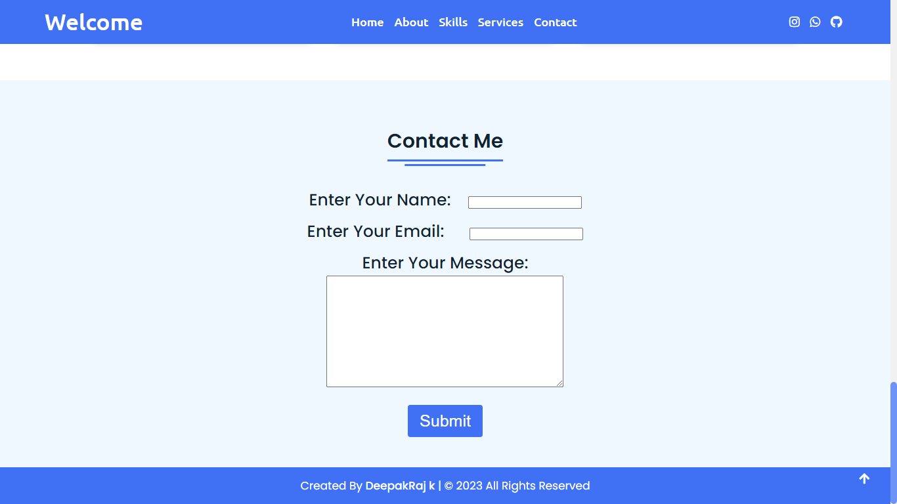

THANK YOU